Behind the scenes of the work in a TOX 4 Lab at Solvias AG

“Bring your innovation to its destination”
This is the guiding principle that Solvias follows every day.
At Solvias, collaboration and innovation go hand in hand, and we had the pleasure of sitting down with their team for an insightful interview. This discussion highlighted the strong partnership between Solvias and SKAN, a collaboration built on trust, expertise, and mutual dedication to advancing safety and precision in pharmaceutical and biotech processes.
In particular, Solvias shared their experience working on the TOX 4 laboratory project, a state-of-the-art facility designed to handle highly toxic substances safely. The centerpiece of this effort is the pure2 isolator, which has exceeded expectations with its safety features, operational reliability and advanced capabilities like the integration of an ultra-microbalance from Mettler Toledo.
The interview sheds light on the seamless collaboration that made this project a success, as well as the significant steps Solvias is taking to ensure occupational safety while pushing the boundaries of analytical excellence. Read on for insights into this exciting partnership and the solutions that continue to drive innovation at Solvias.
A special thanks to Detlef Gestmann, Philip Schwarz and Charlie Brault for taking the time to share their valuable insights and experiences with us. Your feedback and collaboration are greatly appreciated!

Interview Questions
First of all, could you describe the company Solvias in your words?
Solvias is a world leading CRO/CDMO headquartered in Switzerland. Our highly trained scientists deliver unrivaled expertise, service, and value to customers in the pharmaceutical and biotech industry. Drawing on a proven 20+ year track record of scientific excellence, we provide cGMP-compliant contract analytical services to help you bring safe and effective therapies to patients faster. Our capabilities range from characterization of biologics, ATMPs and small molecule drugs and method development, release testing and stability services. We also offer one of the largest ligand portfolios for catalytic transformations and a suite of related custom API synthesis and catalysis technology services. Our experts use a phase-appropriate analytical testing approach to help you navigate the regulatory environment. With ready access to our subject matter experts and professional project management Solvias helps bring customers’ innovation to its destination.

What is the speciality/focus about the site in Kaiseraugst?
The site offers Comprehensive cGMP analytical services, biopharmaceuticals and small molecules, and drug substance and drug product analysis.

What made you decide to partner with SKAN in this project?
We have had a good business relationship with SKAN for several years. The expertise, dedication and initiative that SKAN always shows made it easy for us to decide which company we wanted to work with on the project. During a visit to the ILMAC trade fair in Basel in 2023, we had the chance to see the pure2 isolator live for the first time, meet the people behind it and get an idea of the unit.

What is the scope of your department?
The Department of Health, Safety and Environment (HSE) is involved in this project to ensure the occupational safety of employees and the correct handling of highly toxic (TOX 4) substances with an occupational exposure limit (OEL) below 50 ng/m3.
Our goal is to enable our employees to handle these highly toxic substances safely. To this end, we have worked with an occupational hygienist to determine which parameters are required for setting up a laboratory that can work with such substances. These included the requirement for an isolator. So, together with our laboratory planners, SKAN and various other companies, we planned the so-called TOX 4 laboratory.

How did your process look like before purchasing the pure2?
We could only handle compounds with an OEL > 50 ng/ m3 (Solvias TOX 3)

What made you decide to move your process into an isolator?
The EKAS 1871 (guideline for laboratories) + 2nd edition 2021 – Containment Manual of the ISPE D/A/CH Working Group Containment legally requires that if you work with substances below an OEL of 50 ng/m3, you must work with an isolator.

How does the process look like in the pure2?
Solid sample handling for the TOX 4 samples is only performed inside the isolator. There, the samples are weighed using an ultra-microbalance, diluted with a solvent (e.g. solvent or water), and later the diluted samples are discharged from the isolator. The diluted samples are then analyzed in the TOX 4 laboratory, e.g. characterized using our HPLC.
The qualified ultra-microbalance can weigh up to 3 mg and provides data up to 7 decimal places.

What made you decide, on the pure2 isolator?
On the one hand, it fully meets our expectations in terms of the safety of our employees and the processing of the TOX 4 samples. For example, it is very easy to clean, it has a good disposal system (Lugaia System), it is even possible to install an ultra-microbalance that runs stably, and it offers a very good volume flow in the different modes (from standby to emergency operation). In addition, the pure2 has a certificate for cystatic agents (DIN 12980:2017-05).
All in all, the pure2 is a versatile isolator that not only stands out with its various features but also highlights its wide range of applications.
Furthermore, we have a very good working relationship with SKAN. We know that we can always rely on prompt and effective support from SKAN.

What has been your experience so far with the pure2?
Since it is our first pure2 isolator, we will gain our first experiences in future projects. But so far, the staff have received training from SKAN for the TOX 4 laboratory and we have had very positive experiences so far. One of the biggest successes is the installation of the ultra-microbalance. It was a very exciting project to see if the balance would remain stable at the high air flow.

Impressions
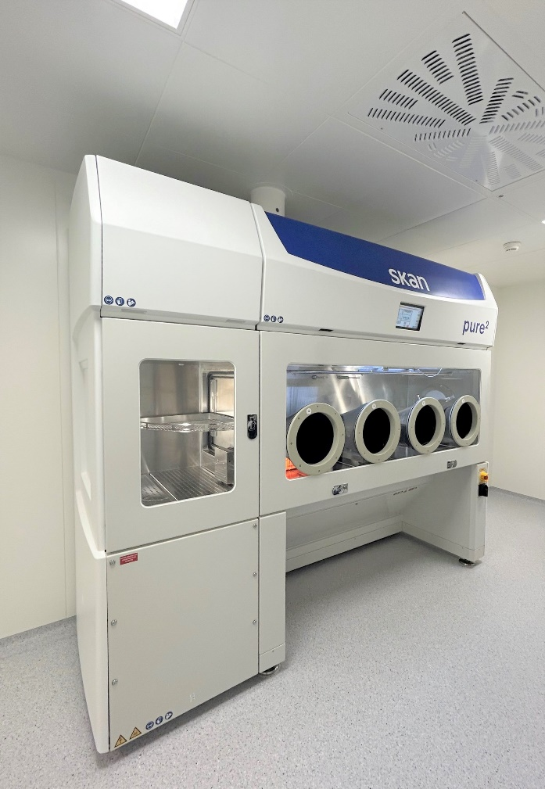

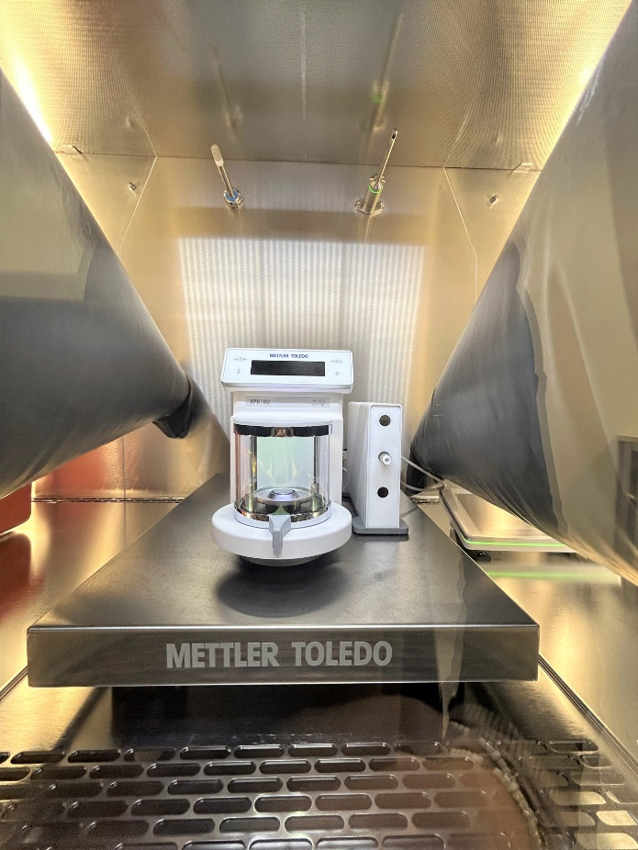

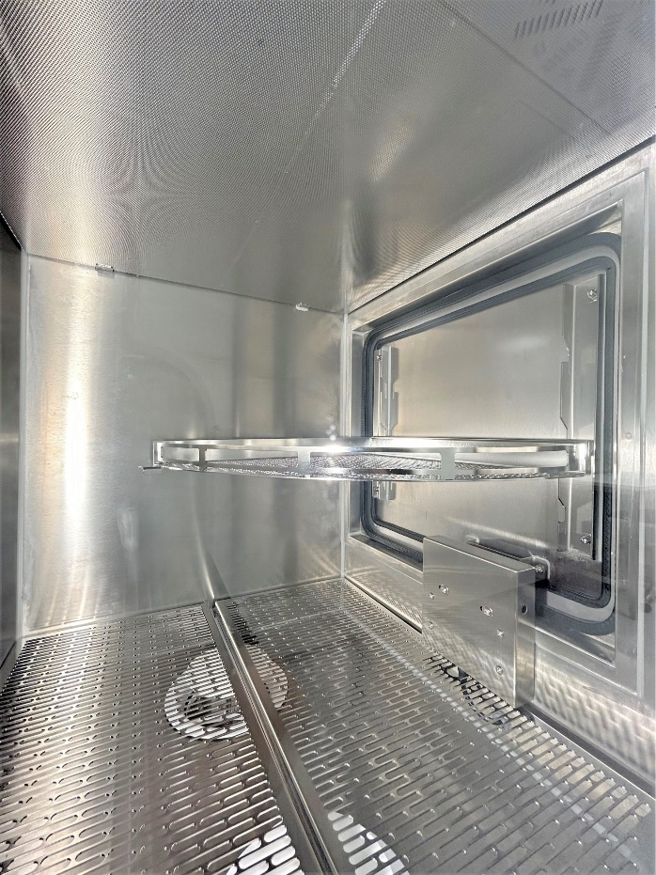

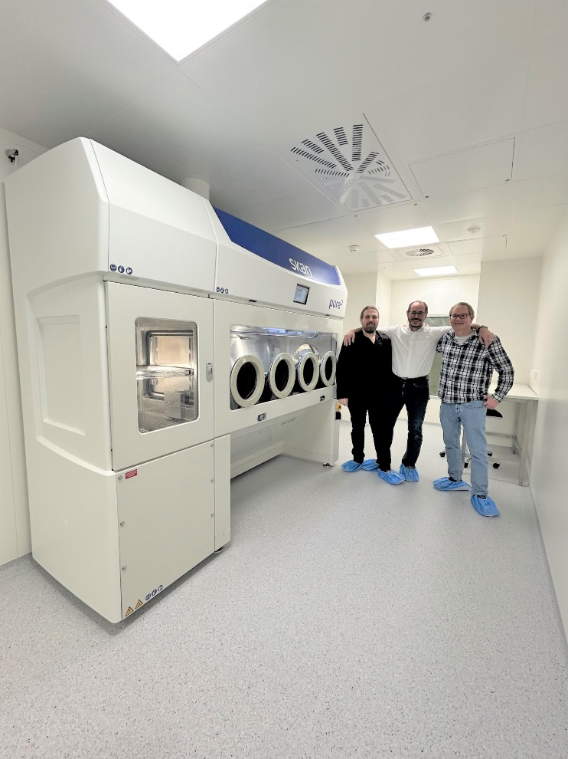

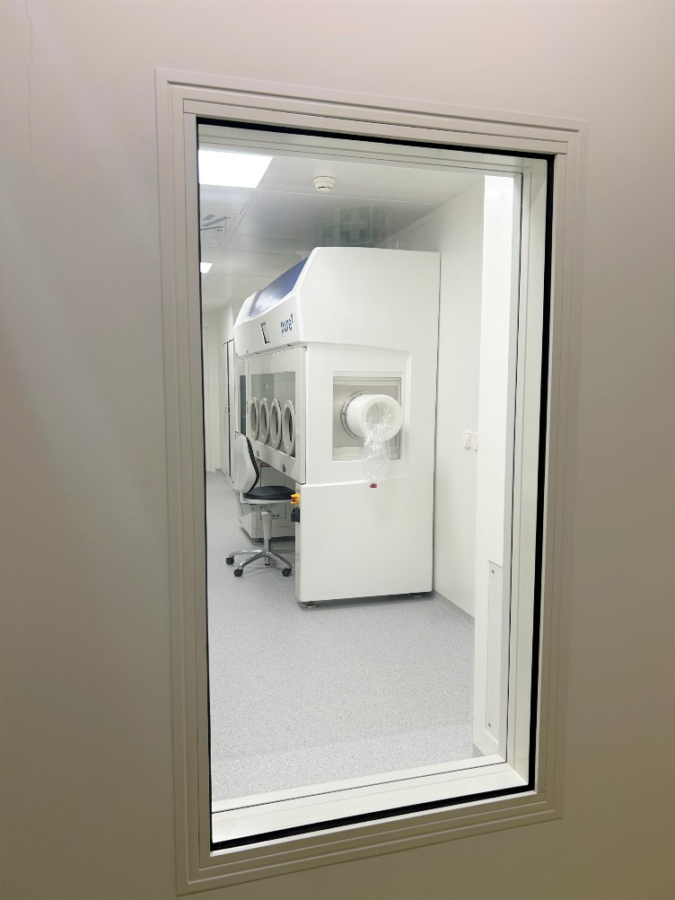

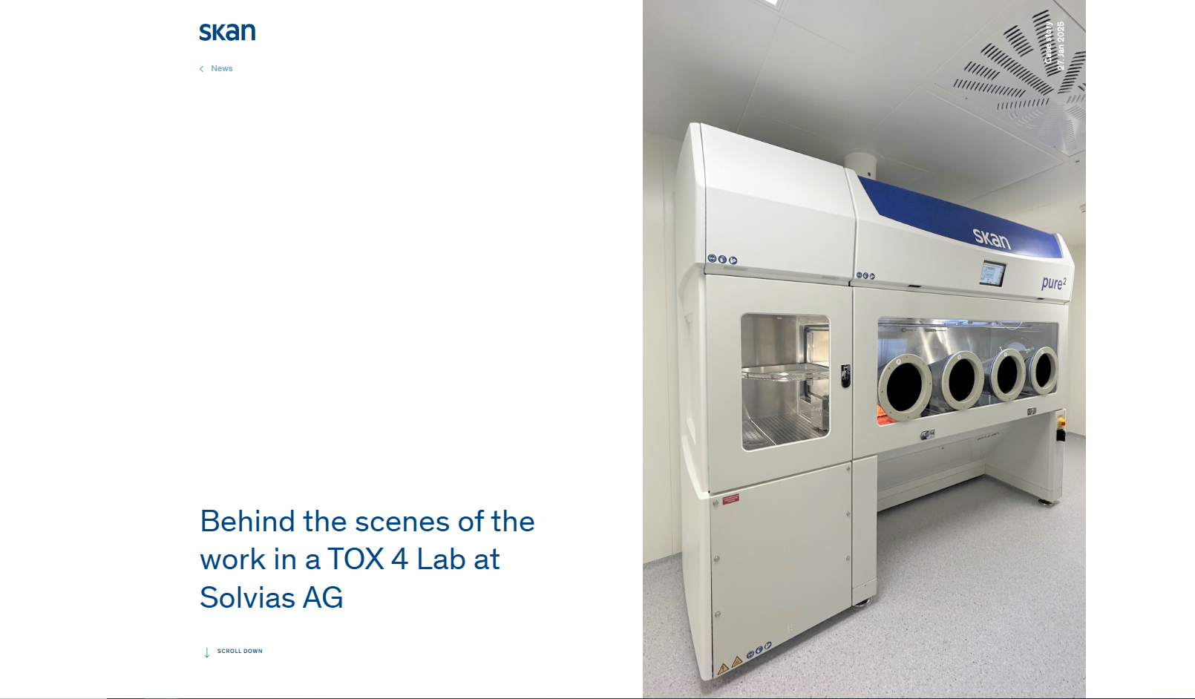
Look & Feel on the Website

